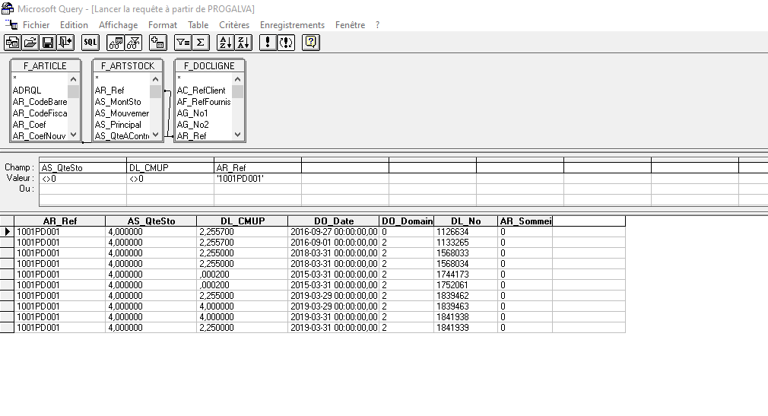

INSTRUCTION SQL

SELECT F_ARTSTOCK.AR_Ref, F_ARTSTOCK.AS_QteSto, F_DOCLIGNE.DL_CMUP, F_DOCLIGNE.DO_Date, F_DOCLIGNE.DO_Domaine, F_DOCLIGNE.DL_No, F_ARTICLE.AR_Sommeil

FROM PROGALVA.dbo.F_ARTICLE F_ARTICLE, PROGALVA.dbo.F_ARTSTOCK F_ARTSTOCK, PROGALVA.dbo.F_DOCLIGNE F_DOCLIGNE

WHERE F_ARTSTOCK.AR_Ref = F_DOCLIGNE.AR_Ref AND F_DOCLIGNE.AR_Ref = F_ARTICLE.AR_Ref AND ((F_ARTSTOCK.AS_QteSto<>0) AND (F_DOCLIGNE.DL_CMUP<>0) AND (F_ARTSTOCK.AR_Ref='1001PD001'))