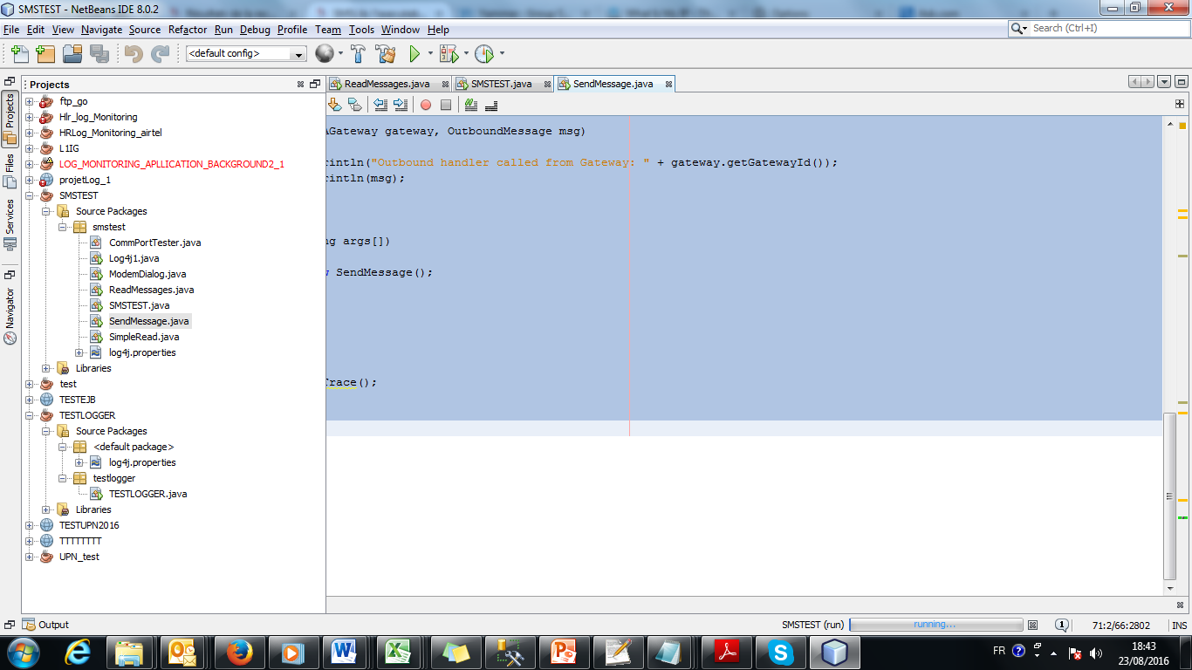

log4j.rootCategory=DEBUG, file , STDOUT

# Stdout

log4j.appender.STDOUT=org.apache.log4j.ConsoleAppender

log4j.appender.STDOUT.Target=System.out

log4j.appender.STDOUT.layout=org.apache.log4j.PatternLayout

log4j.appender.STDOUT.layout.ConversionPattern=[%d{ISO8601}]%5p%6.6r[%t]%x - %C.%M(%F:%L) - %m%n

# File

log4j.appender.file=org.apache.log4j.RollingFileAppender

log4j.appender.file.File=D:\\SOFT AND DOC\\JAVA\\SMSTEST\\log4j1.log

# Control the maximum log file size

log4j.appender.file.MaxFileSize=1000KB

# Archive log files (10 backup files here cycling)

log4j.appender.file.MaxBackupIndex=10

log4j.appender.file.layout=org.apache.log4j.PatternLayout

log4j.appender.file.layout.ConversionPattern=[%d{ISO8601}]%5p%6.6r[%t]%x - %C.%M(%F:%L) - %m%n