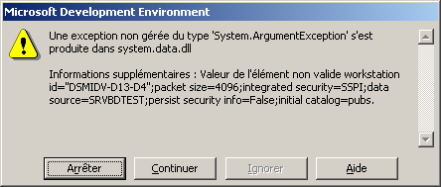

IPermission class="System.Data.SqlClient.SqlClientPermission, System.Data, Version=1.0.5000.0, Culture=neutral, PublicKeyToken=b77a5c561934e089"

